******aIndustrial Project Report**

*Submitted in partial fulfillment of the degree of*

**Btech in Electrical Engineering**

**By**

***SOURADIP DAS[11901620007]***

***Saroj Kumar Gouda [11901620006]***

***Aditya Thakur[11901621036]***

**Third-year student of**

**SILIGURI INSTITUTE OF TECHNOLOGY**

*THIS IS SUBMITTED IN FULFILLMENT OF THE REQUIREMENTS FOR THE DEGREE OF*

**AFFILIATED TO**

**Maulana Abul Kalam Azad University of Technology**

**Under the supervision of**

Mr. Ripam Kundu

**Sikharthy Infotech Pvt. Ltd.**

***Covid19 Data Analysis***

By

*SOURADIP DAS[11901620007]*

*Saroj Kumar Gouda [11901620006]*

*Aditya Thakur[11901621036]*

UNDER THE GUIDANCE OF

**Mr. Ripam Kundu**

**Project Guide**

**Sikharthy Infotech Pvt. Ltd.**

*THIS IS SUBMITTED IN FULFILLMENT OF THE REQUIREMENTS FOR THE DEGREE OF*

**B.Tech**

IN

Electrical Engineering

**SILIGURI INSTITUTE OF TECHNOLOGY**

**AFFILIATED TO**

**Maulana Abul Kalam Azad University of Technology**

**Department of Electrical Engineering**

I hereby forward the documentation prepared under my supervision by **Ripam Kundu Sir** entitled **Siliguri Institute Of Technology** to be accepted as fulfillment of the requirement for the Degree of Bachelor of Technology in Electrical Engineering, **Siliguri Institute Of Technology** affiliated to **Maulana Abul Kalam Azad University of Technology** (**MAKAUT**).

|  |  |
| --- | --- |
| ____________________________________________________    **Mr.Ripam Kundu**  **(Software Developer)**  **Project Guide**  **Sikharthy Infotech Pvt. Ltd.**  **Shilpi Ghosal**  **(Director)**  **Sikharthy Infotech Pvt. Ltd.** | ____________________________________________________    **HOD**  **Department Of Electrical Engineering, SIT** |

**TPO**

**Siliguri Institute of Technology**

**Certificate of Approval**

The foregoing project is hereby approved as a creditable study for the B.Tech in Electrical Engineering presented in a manner of satisfactory to warrant its acceptance as a prerequisite to the degree for which it has been submitted. It is understood that by this approval the undersigned do not necessarily endorsed or approved any statement made, opinion expressed or conclusion therein but approve this project only for the purpose for which it is submitted.

Final Examination for

Evaluation of the Project ----------------------------------------

-----------------------------------------

------------------------------------------

**Signatures of Examiners**

**ABSTRACT**

*.* *It feels surreal to imagine how the virus began to spread from one person that is patient zero to four million . It was possible because of the transport system. As COVID-19 has swept across the world, we have seen first-hand how a disease outbreak without the tools to halt and treat it can disrupt health systems, economies and threaten vulnerable populations.*

*This has in turn led many governments to wake up to the importance of pandemic and preparedness involved in the fight against drug-resistant infections must step up efforts to ensure antibiotic resistance is prioritized as foremost a health security challenge, while persuading policymakers that the best way to meet this challenge is through public-health centered strategies and approaches.*

*To be well prepared for any future pandemic we need to analysis the current covid19 pandemic.Analysis Of The data of Covid 19 will help us to undersatand where we made mistakes and gow to prevent it.*

*So, the main goal of the project is to analyze the Covid 19 data*

**ACKNOWLEDGEMENT**

It is a great pleasure for me to acknowledge the assistance and participation of a large number of individuals in this attempt. Our project report has been structured under the valued suggestion, support, and guidance of **Mr. Ripam Kundu**. Under his guidance, we have accomplished the challenging task in a very short time.

Finally, we express our sincere thankfulness to our family members for inspiring me all throughout and always encouraging us.

**Group Member Signature**

**TABLE OF CONTENTS**

Chapter 1: Introduction

1: Introduction 8

Chapter 2: What We Used

2.1: Python 9-10

2.2: Pandas

2.2: Numpy

2.3: Matplotlib

Chapter 3: Functionality

3.1: Working Principle 11-14

Chapter 4: Functional Requirement of the System

4.1: Software Requirement 15-

Chapter 5: Code and Snapshots 16-18

5.1: Codes

5.2: Snapshots

Chapter 6: Conclusion 19

Chapter 7: References 20

**INTRODUCTION**

*As COVID-19 has swept across the world, we have seen first-hand how a disease outbreak without the tools to halt and treat it can disrupt health systems, economies and threaten vulnerable populations.*

*This has in turn led many governments to wake up to the importance of pandemic and preparedness involved in the fight against drug-resistant infections must step up efforts to ensure antibiotic resistance is prioritized as foremost a health security challenge, while persuading policymakers that the best way to meet this challenge is through public-health centered strategies and approaches.*

*To be well prepared for any future pandemic we need to analysis the current covid19 pandemic.Analysis Of The data of Covid 19 will help us to undersatand where we made mistakes and gow to prevent it.*

**WHAT WE USED**

1. **Python: -**

**P**ython is a popular programming language. It was created by Guido van Rossum, and released in 1991.

It is used for:

* web development (server-side),
* software development,
* mathematics,
* system scripting.
* Machine Learning

**2.Numpy: -**

NumPy is a Python library used for working with arrays.

It also has functions for working in domain of linear algebra, fourier transform, and matrices.

NumPy was created in 2005 by Travis Oliphant. It is an open source project and you can use it freely.

NumPy stands for Numerical Python.

In Python we have lists that serve the purpose of arrays, but they are slow to process.

NumPy aims to provide an array object that is up to 50x faster than traditional Python lists.

The array object in NumPy is called ndarray, it provides a lot of supporting functions that make working with ndarray very easy.

Arrays are very frequently used in data science, where speed and resources are very important

**3, Pandas :-**

Pandas is an open-source library that is made mainly for working with relational or labeled data both easily and intuitively. It provides various data structures and operations for manipulating numerical data and time series. This library is built on top of the NumPy library. Pandas is fast and it has high performance & productivity for users.

**Advantages**

* Fast and efficient for manipulating and analyzing data.
* Data from different file objects can be loaded.
* Easy handling of missing data (represented as NaN) in floating point as well as non-floating point data
* Size mutability: columns can be inserted and deleted from DataFrame and higher dimensional objects
* Data set merging and joining.
* Flexible reshaping and pivoting of data sets
* Provides time-series functionality.
* Powerful group by functionality for performing split-apply-combine operations on data sets.

**4. Matplotlib :-**

Matplotlib is an amazing visualization library in Python for 2D plots of arrays. Matplotlib is a multi-platform data visualization library built on NumPy arrays and designed to work with the broader SciPy stack. It was introduced by John Hunter in the year 2002.

One of the greatest benefits of visualization is that it allows us visual access to huge amounts of data in easily digestible visuals. Matplotlib consists of several plots like line, bar, scatter, histogram etc.

**FUNCTIONALITY**

**WORKING PRINCIPLE:**

Importing Dataset on Covid-19 India case time series

data = pd.read_csv('case_time_series.csv')

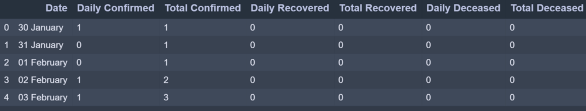

case_time_series.csv dataset has 7 column. We will be collecting Daily Confirmed  Daily Recovered and Daily Deceased in variables as array.

Y = data.iloc[61:,1].values #Stores Daily Confirmed

R = data.iloc[61:,3].values #Stores Daily Recovered

D = data.iloc[61:,5].values #Stores Daily Deceased

X = data.iloc[61:,0] #Stores Date

‘*Y’*variable stores the ‘Daily Confirmed’ corona virus cases

‘*R’*variable stores the ‘Daily Recovered’ corona virus cases

‘D*’*variable stores the ‘Daily Deceased’ corona virus cases

And ‘X’ variable stores the ‘Date’ column

**Plotting Simple Plot**

We’ll be following the object-oriented method for plotting. The plot function takes two arguments that are X-axis values and Y-axis values plot. In this case, we will pass the ‘X’ variable which has ‘Dates’ and ‘Y’ variable which has ‘Daily Confirmed’ to plot.

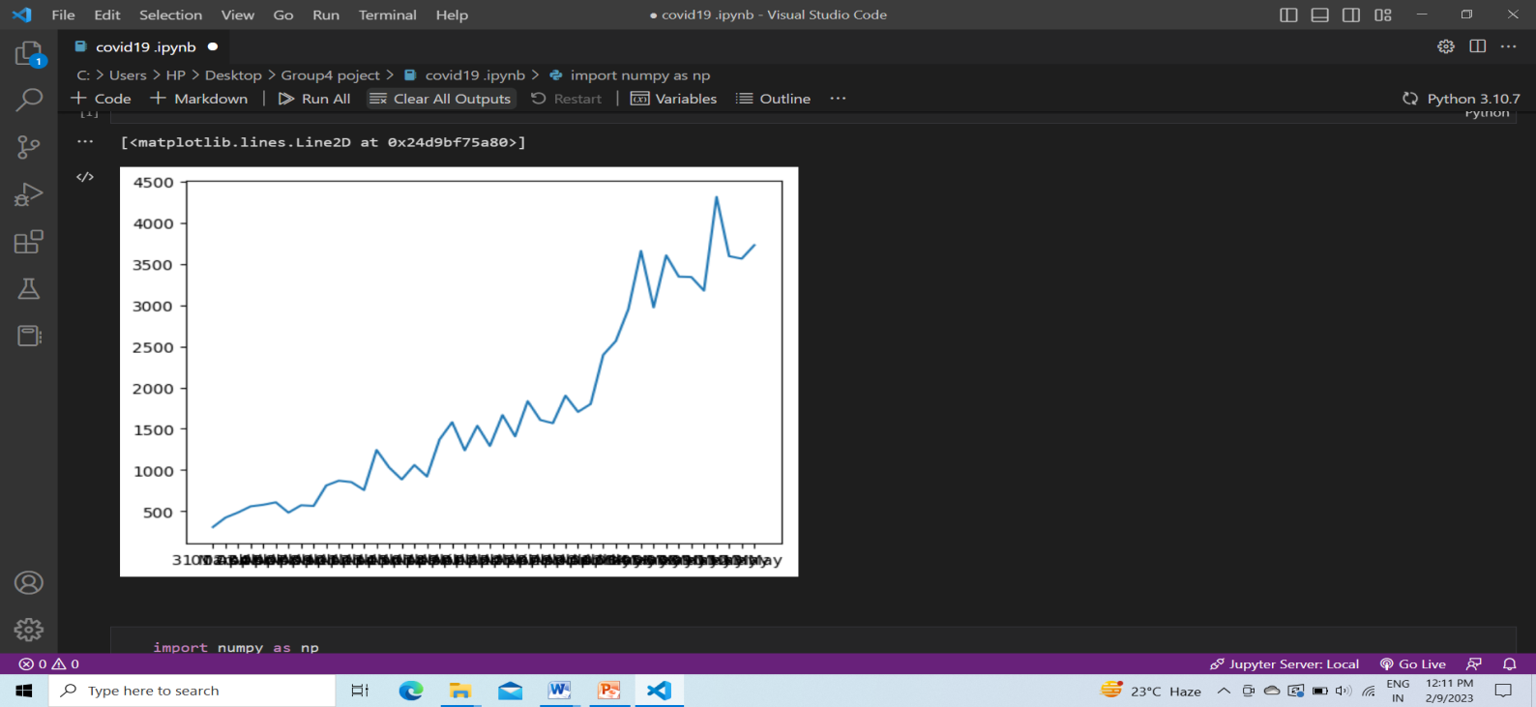

To have control over the aesthetics of the graph such as labels, titles, color and size we shall apply more functions as shown below.

plt.figure(figsize=(25,8))

This creates a canvas for the graph where the first value ‘25’ is the width argument position and ‘8’ is the height argument position of the graph.

ax = plt.axes()

Let’s create an object of the axes of the graph as ‘ax’ so it becomes easier to implement functions.

ax.grid(linewidth=0.4, color='#8f8f8f')

‘.grid’ function lets you create grid lines across the graph. The width of the grid lines can be adjusted by simply passing an argument ‘linewidth’ and changing its color by passing ‘color’ argument.

ax.set_facecolor("black")

ax.set_xlabel('\nDate',size=25,

color='#4bb4f2')

ax.set_ylabel('Number of Confirmed Cases\n',

size=25,color='#4bb4f2')

‘.set_facecolor’ lets you set the background color of the graph which over here is black. ‘.set_xlabel’ and ‘.set_ylabel’ lets you set the label along both axes whose size and color can be altered .

ax.plot(X,Y,

color='#1F77B4',

marker='o',

linewidth=4,

markersize=15,

markeredgecolor='#035E9B')

Now we plot the graph again with ‘X’ as Dates and ‘Y’ as Daily Confirmed by calling plot function. The plotting line , marker and color can be altered by passing color, linewidth?—?to change color and adjust the width of plotting line and marker, markersize, markeredgecolor?—?to create marker which is the circle in this case, adjust the size of the marker and define marker’s edge color

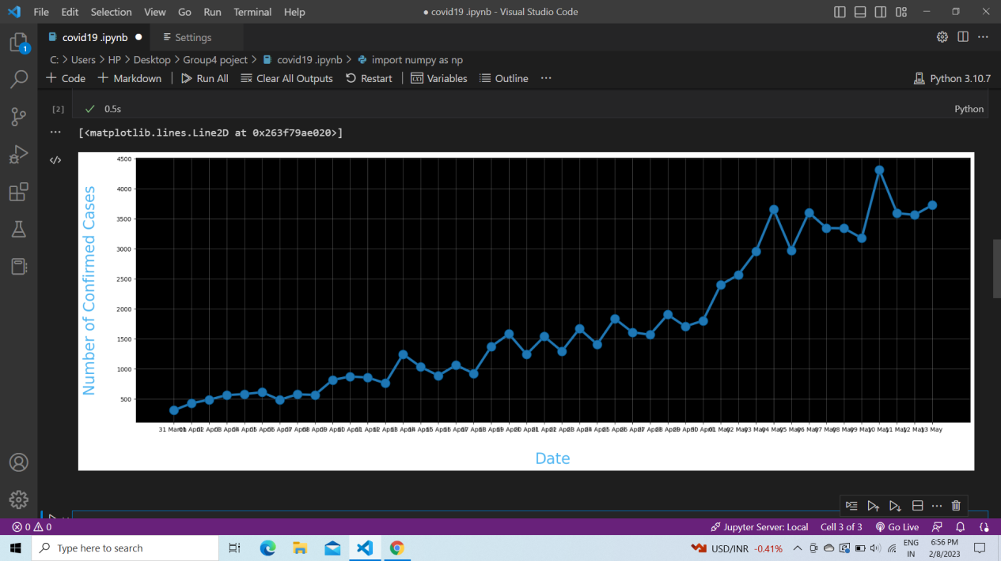

**Pie Chart**

We’ll be plotting the Transmission Pie Chart to understand the how the virus is spreading based on Travel, Place Visit and Unknown reason.

**Initializing Dataset**

slices = [62, 142, 195]

activities = ['Travel', 'Place Visit', 'Unknown']

So we have created list slices based on which our Pie Chart will be divided and the corresponding activities are it’s valued

To plot a Pie Chart we call ‘.pie’ function which takes x values which is ‘slices’ over here based on it the pie is divided followed by labels which have the corresponding string the values it represents. These string values can be altered by ‘textprops’. To change the radius or size of Pie we call ‘radius’. For the aesthetics we call ‘shadow’ as True and ‘startangle ’= 90. We can define colors to assign by passing a list of corresponding colors. To space out each piece of Pie we can pass on the list of corresponding values to ‘explode’. The ‘autopct’ defines the number of positions that are allowed to be shown. In this c ase, autopct allows 2 positions before and after the decimal place.

**FUNCTIONAL REQUIREMENTS OF THE SYSTEM**

***SOFTWARE:***

* *Operating System*
* Windows OS 11

***WEB BROWSER:***

* Internet Explorer 7

. Google Chrome

**CODE AND SNAPSHOTS**

Code🡪

import numpy as np

import pandas as pd

import matplotlib.pyplot as plt

data = pd.read_csv('covid_19_patient_datas.csv')

Y = data.iloc[61:,1].values

R = data.iloc[61:,3].values

D = data.iloc[61:,5].values

X = data.iloc[61:,0]

plt.plot(X,Y)

Snapshots-🡪

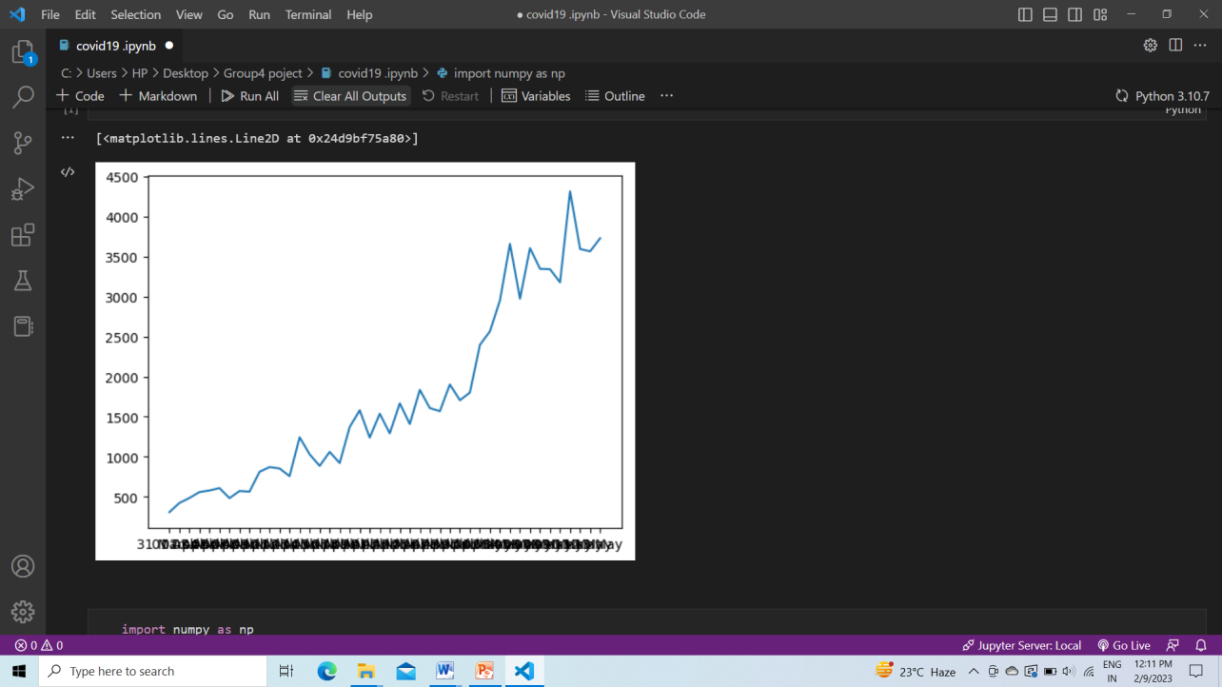

Code🡪

import numpy as np

import pandas as pd

import matplotlib.pyplot as plt

data = pd.read_csv('covid_19_patient_datas.csv')

Y = data.iloc[61:,1].values

R = data.iloc[61:,3].values

D = data.iloc[61:,5].values

X = data.iloc[61:,0]

plt.figure(figsize=(25,8))

ax = plt.axes()

ax.grid(linewidth=0.4, color='#8f8f8f')

ax.set_facecolor("black")

ax.set_xlabel('\nDate',size=25,color='#4bb4f2')

ax.set_ylabel('Number of Confirmed Cases\n',

            size=25,color='#4bb4f2')

ax.plot(X,Y,

        color='#1F77B4',

        marker='o',

        linewidth=4,

        markersize=15,

        markeredgecolor='#035E9B')

Snapshots-🡪

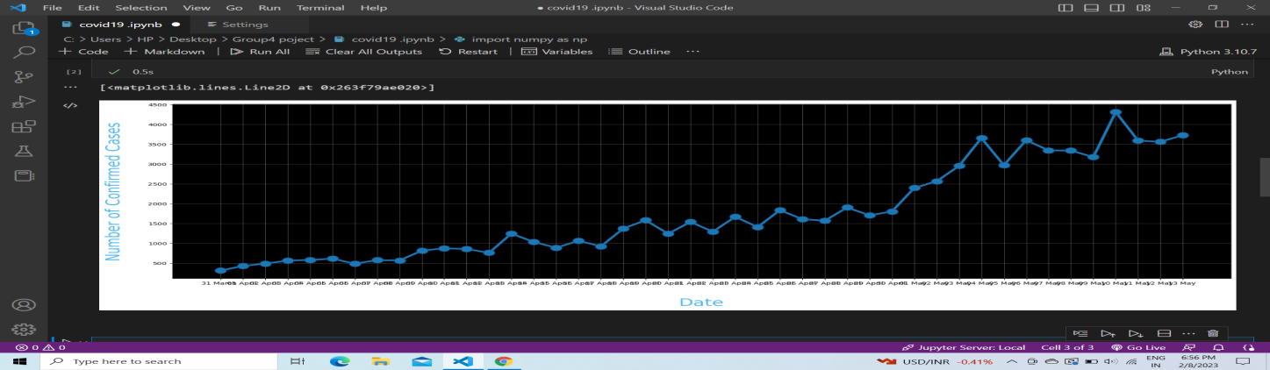

Code🡪

import numpy as np

import pandas as pd

import matplotlib.pyplot as plt

data = pd.read_csv('covid_19_patient_datas.csv')

slices = [62, 142, 195]

activities = ['Travel', 'Place Visit', 'Unknown']

cols=['#4C8BE2','#00e061','#fe073a']

exp = [0.2,0.02,0.02]

plt.pie(slices,labels=activities,

        textprops=dict(size=25,color='black'),

        radius=3,

        colors=cols,

        autopct='%2.2f%%',

        explode=exp,

        shadow=True,

        startangle=90)

plt.title('Transmission\n\n\n\n',color='#4fb4f2',size=40)

Snapshots-🡪

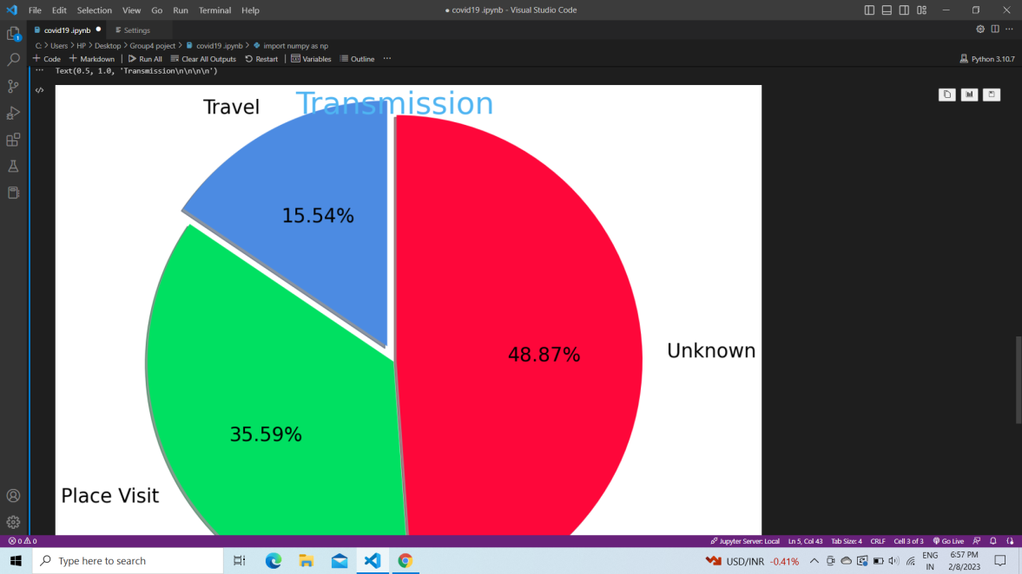

**CONTRIBUTION**

The entire project was divided among our team members.

Souradip Das did the coding part.

Saroj Kumar Gauda made the report

Aditya Thakur helped in making the report.

**CONCLUSION**

At first, there were many reasons why the model didn’t work, it was showing many error than we analyse the code and debug it.

We divided the work among our team member.

In this project, we have developed a python Machine Learning project to analyse the number of covid19 cases

**REFERENCE**

1. **Wikipedia**
2. **Kaggle**
3. **Books on Machine Learning**